MVP Individual Contribution and Collaboration Report (General)
Student Id and Name | Muhammad Aarim Rana – 2213214 (Software Developer)
Group Name | The Best Coders Project
MVP Video Link
MVP Repository Link

Describe your main contribution to the project including meetings, work in the repository and features demonstrated in the video:
For my part of the contribution, I had to collaborate with my group and with my peer who also worked in software. I have managed to develop a University of Wolverhampton working home page which directs the user to contact, library, 24/7 support, courses and student’s page.

In the Github repository, it includes all the work that I have contributed to our group project.

What new skills have you learned while working on this group project and how might they be useful in the future?
The skills that I have learned are: we can work in team and learn how to communicate definitely for proper planning and how to deal with situations that might be making us struggle during the project.

Discuss any new ideas or knowledge you have gained through team interacting with other members of the team:
The ideas that I have gained that we should have a login page and registration page (in case anyone don’t have their accounts).

We discussed how our website will look like than I have started to work on our webpage application.

We were able to share ideas that will help everyone to work in their own time for their part of the group project.

What were the biggest challenges you faced as an individual and as a team and how did you handle them?

If you were to attempt this work again, how would you approach it differently:

Individual Contribution (Role Specific)

Role(S)

Describe the significant contributions you made in your role(s), particularly technical or strategic decisions

Evidence of good collaboration

Good communication and file sharing
Receivable evidence includes:
- Emails and other types of messages (Facebook messenger, WhatsApp etc.)
- Screenshots of Basecamp conversations in which you actively participate.
- Screenshots showing files (designs, reports) that you shared with your team on Basecamp
Important: Please include no more than 5 items
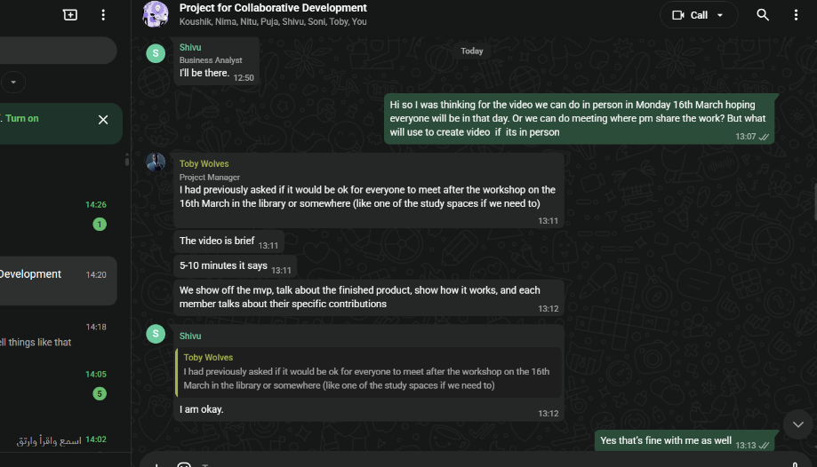
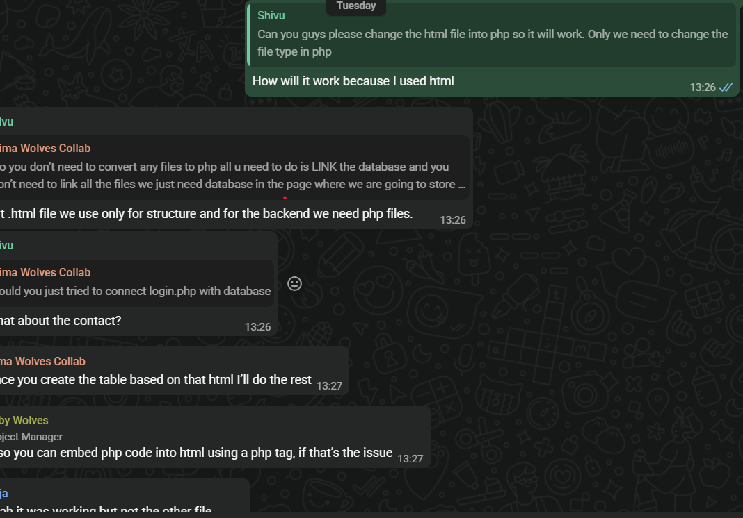

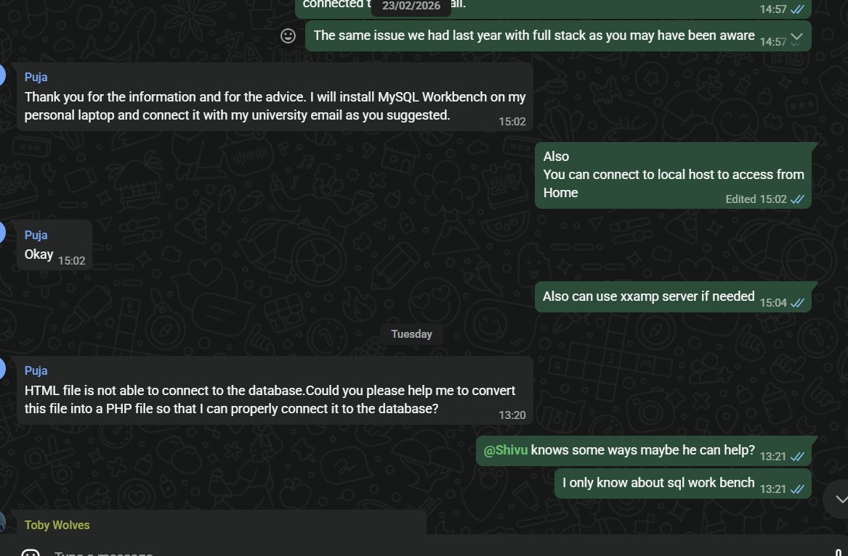
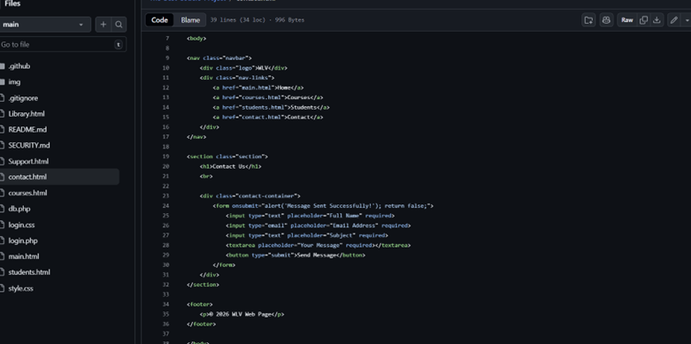

Issue tracking
Receivable evidence includes:
- Screenshots of personal contributions to GitHub issues.
Important: Please include no more than 5 items

